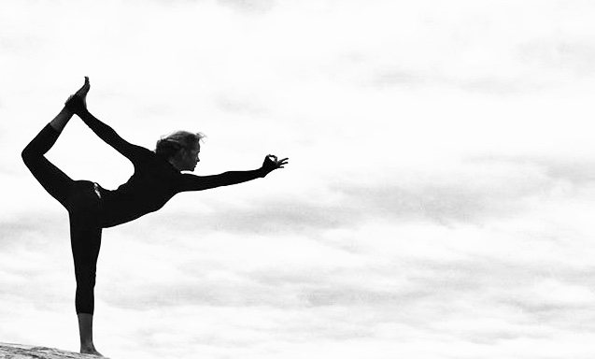
River Yoga VIRTUAL Schedule: ARRIL 2021

M O N D A Y
GENTLE YOGA WITH LIZ
9-10AM
This gentle class will focus on aligning the body with the breath while cultivating stability and ease.

HAPPY HOUR FLOW WITH LIZ
4:30-5:30PM
This one-hour vinyasa style class will awaken your body, mind and spirit and will leave you feeling liberated and full of joy!

T U E S D A Y
MINDFUL BASICS FL0W WITH LIZ
9-10AM
Join Liz for this all-levels gentle flow. Focus on breath, movement and intention to cultivate peace and ease in your day!

FREE COMMUNITY CHAIR WITH LORI
1-2PM AVAILABLE ON FACEBOOK ONLY
This free class will address alignment and breath with the support of the chair. Perfect for our senior population and those with limitations.

MOVING MEDITATIVE FLOW WITH LIZ
5:30-6:30PM
Join Liz for this all-levels gentle flow. Focus on alignment and breath and create your own unique practice.

W E D N E S D A Y
FREE “YOGA4CANCER” INTRO CLASSES WITH TISA
APRIL 14TH, 21ST, 28TH
10:30-11:30AM
This practice combines breath and movement to relieve long and short-term side effects of cancer and its treatments. For more information or to sign in – Tisa 315-749-6155.

www.riveryoga.net 315-523-0627 234 James Street Clayton, NY

T H U R S D A Y
THE ANATOMY OF YOGA WITH LORI
9-10AM
Explore proper alignment and breath and create a practice you love! All levels. Great for beginners.

DEEP CORE WITH LIZ
5:30-6:30PM
Challenge yourself! Build strength, endurance and
flexibility while focusing on the breath. This warm one hour music inspired class will leave you feeling invigorated and detoxified! Modifications and variations offered. All levels.

F R I D A Y
HAPPY HOUR FLOW WITH LIZ
4:30-5:30PM
This slow vinyasa style class will awaken your body and spirit and will leave you feeling liberated and full of joy! All levels.

S A T U R D A Y
NO VIRTUAL CLASSES AVAILABLE AT THIS TIME

S U N D A Y
NO VIRTUAL CLASSES AVAILABLE AT THIS TIME

LOOK FOR MORE VIRTUAL “POP-UP” CLASSES ON OUR WEBSITE/MINDBODY!

ALL VIRTUAL CLASSES ON WEBSITE/MINDBODY, EXCEPT OUR FREE COMMUNITY CHAIR CLASS WHICH IS AVAILABLE ON FACEBOOK ONLY. CALL/TEXT LIZ FOR EASY ACCESS TO CLASSES/ QUESTIONS.

